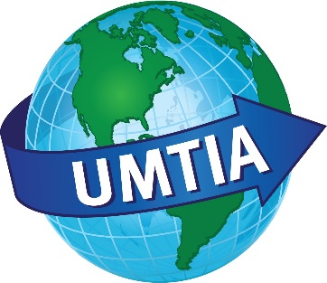

UMTIA Mass Mailing Policy
Updated February 2018

S

Per the decisions made at the UMTIA Board Meeting on 2/8/2018, the following types of notices will be circulated to the UMTIA membership.

*To be circulated via mass email from the Membership Director or another Board member to all current members:

- Employment notices related to the interpreting/translating profession that include benefits.
- Advocacy letters issued by UMTIA
- Announcements from the ATA

*To be circulated via selected email from the Membership Director or another Board member to specific groups of members (typically language groups):

- Training or job opportunities that might not meet the criteria of being from nonprofits or having benefits, but since they are language specific might be of interest to that group or are unusual opportunities

**To be added to the website, posted to the “News & Current Events” blog, and/or posted to Facebook by the Media Manager:

- Announcements from sister organizations such as MATI, IITA, CCHI, ISG, etc. if of possible interest to the membership
- Announcements from the Translation and Interpretation programs at Century College or the University of Minnesota
- Training opportunities, conferences, and meetings of interest to translators and interpreters, both local and worldwide
- Job postings from nonprofits that may or may not include benefits
- Volunteer opportunities
- Advocacy opportunities
- News stories of interest to interpreters and translators

*Please note that items that are circulated via mass email to members may also be added to the website, posted to the “News & Current Events” blog, and/or posted to Facebook.

**Final discretion of any publication remains with the UMTIA Executive Board.

